BLOGPOST - Understanding Customer Acquisition Costs - The Framework VCs Use

An area I have wrestled with as a VC over the last five years is how to really understand the unit economics of businesses. The basic concept of LTV>CPA (lifetime value greater than cost to acquire) is pretty simple. The complexity comes when you try to work out what will happen to these economics as the business scales.
I’m not going to get into lifetime value calculations here, as it is well covered elsewhere e.g. by Bill Gurley here. Where I’d like to focus is on CPA.
Often as a VC you are presented with a headline CPA figure and nothing more. This can look good on the surface but mask underlying issues. For example, take an early stage eCommerce business with an LTV of €30 and an overall CPA of €20. This looks like a solid business. Digging deeper, 50% of users are acquired through free channels (PR, SEO) and so the CPA for the remaining 50% (acquired through SEM) is €40. The free channels are often hard to scale up rapidly, so if the company wants to grow fast post-investment the obvious route is SEM. However, in this case customer acqusition through SEM is uneconomic (LTV of €30 is less than CPA of €40). As a VC you then start to worry about whether this business can grow fast in a rational way.

Below is a framework to take account of these mix effects and think about CPA in more depth:
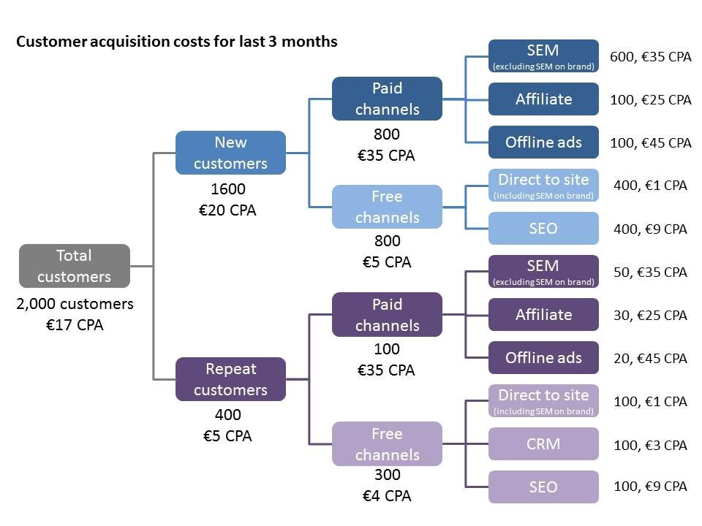

The idea is to break down overall CPA into spend that attracts new customers, vs. bringing back old customers, and then to break down the major acquisition channels free vs. paid
Points to note:
- It is important to think about CPA, not CPV (cost per visitor), as the conversion rate from visitor to customer often varies dramatically by channel. (CPA = CPV / conversion rate). For example conversion rate is usually much higher for SEM than for PR-driven direct visitors
- Measuring the impact of offline advertising (TV, Outdoor) is hard but possible. Two approaches are possible: use a unique URL (or voucher code) on your offline ads; or measure the uplift in direct site visits when you are running offline advertising compare to immediately before. Neither are perfect but both are better than guesswork
- Don’t include SEM spend on your brand terms within your SEM CPA. Clicks on your brand terms will have a much lower CPA, best to think about them in the same way as direct visitors to your site.
- The only truly free channel is people directly typing in your URL. Other ‘free’ channels (SEO, CRM) have some variable cost which you should account for (although you shouldn’t include the initial investment to put SEO or CRM in place as this is a one time cost).
- Differentiating between acquisition costs of new vs. returning visitors requires investing time and money into your web analytics system. When you are starting out you won’t have meaningful returning visitors so this doesn’t need to be a priority.
- For the sake of simplicity I haven’t included all possible channels (e.g. targeted display ads, social) but these can be treated the same way

Some caveats / limitations:
- The framework assumes ‘last click’ attribution. (for more info on attribution start here) This is often a reasonable assumption to make for products that are bought immediately, but for longer sales cycles you should think about developing a fuller attribution methodology. As you become even more sophisticated you can try to build in the ‘halo’ effect of brand advertising.
- Building on the point above, the framework does not include retargeting. Probably the easiest way to think about retargeting is as a separate channel, but it depends on other paid marketing (which is where proper attribution becomes more important).
- Analysis can get tricky when you are first signing customers up for a mailing list or free product, and only later try to convert them to paid. In an ideal world you would start with the moment where user pays, and track back all the marketing costs from there. However this can get very complex. Usual compromise is to just compare ‘Cost per Sign Up’ across marketing channels.
- If you are making extensive use of discounts (Groupon, first box free) you need to take these into account in your acquisition costs, and assign them to the correct channel
- This a web-centric framework but principles for mobile are exactly the same.

Once you have mapped out your customer acquisition costs along the lines of the above you need to think about the implications. One way to do this is the following:
- What can I realistically reduce my CPA to in each channel in the next year (by getting more sophisticated in SEM, increasing conversion rates)?
- What can I realistically increase my LTV by in the next year (by increasing repeat, improving margins)?
- Would each of my acquisition channels make sense at this CPA and LTV? If not, turn off the ones that don’t.
Then it is time to think about growth:
- What can I do to grow volume of acquisitions through my free channels? (pro tip: if you have a customer base the best place to start is CRM). What is a realistic target for this?
- What is likely to happen to CPA in my paid channels as I grow spend? What limits will I hit? Typically CPA will start high, go down as you become more sophisticated, then start to creep up as you start looking for volume from less relevant search terms or with broader targeting. Common mistake is to take your CPA from highly relevant long tail SEM and assume this will also apply for the most popular ‘head’ terms in the category.
- Are there other marketing channels I should be looking at? Direct response TV and outdoor ads seem to work well for some online businesses (particularly those on mobile), but not all for others. Often the best value can be found by being first to optimize for a new audience (e.g. Instagram, Snapchat).
- Start layering in paid acquisition, starting with the cheapest channels, until you hit your maximum budget or CPA creeps up too high.
Apologies if the above is a little theoretical — as always the theory is 10% of the battle here, 90% is execution and making sure you have accurate granular data to work with. Would love some ‘real world’ feedback. That being said, the best marketing operations I have seen (Lovefilm, The Hut, Wooga, Housetrip) have a really strong grasp of the theory above.

Aus <https://medium.com/venture-capital-growth-hacking/understanding-customer-acquisition-costs-74aec7538b4d>

